This Pied Piper of Hamelin https://nrich.maths.org/8315

Age 7 to 11


"The Pied Piper of Hamelin'' is a story you may have heard or read. This man, who is often dressed in very bright colours, drives the many rats out of town by his pipe playing - and the children follow his tune.
Suppose that there were 100 children and 100 rats. Supposing they all have the usual number of legs, there will be 600 legs in the town belonging to people and rats.
But now, what if you were only told that there were 600 legs belonging to people and rats but you did not know how many children/rats there were?
The challenge is to investigate how many children/rats there could be if the number of legs was 600. To start you off, it is not too hard to see that you could have 100 children and 100 rats; or you could have had 250 children and 25 rats. See what other numbers you can come up with.
Remember that you have to have 600 legs altogether and rats will have 4 legs and children will have 2 legs.
When it's time to have a look at all the results that you have got and see what things you notice you might write something like this:
a) 100 Children and 100 Rats - the same number of both,
b) 150 Children and 75 Rats - twice as many Children as rats,
c) 250 Children and 25 Rats - ten times as many Children as Rats.
This seems as if it could be worth looking at more deeply. I guess there are other things which will "pop up'', to explore.
Then there is the chance to put the usual question "I wonder what would happen if ...?''

Money Bags https://nrich.maths.org/1116

Age 5 to 11

Ram divided 15 pennies among four small bags.
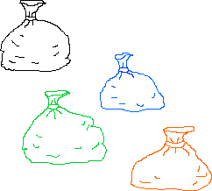
He labelled each bag with the number of pennies inside it.
He could then pay any sum of money from 1p to 15p without opening any bag.
How many pennies did Ram put in each bag?
This problem is based on Money Bags from 'Mathematical Challenges for Able Pupils Key Stages 1 and 2', published by DfES. You can download a copy here.

Counting Cards https://nrich.maths.org/1843

Age 7 to 11
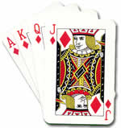
A magician took a suit of thirteen cards and held them in his hand face down.

He took the top card off the pile and put it at the bottom , saying 'A' as he did it. He took the next card and said 'C' as he put it at the bottom. He took the next card and turned it over, saying 'E' as he did it - and the card was an ACE!

He carried on with the letters T-W-O and as he said the 'O' he turned over the card and it was a TWO!

He carried on with T-H-R-E-E, the FOUR and so on, and in each case as he said the last letter of the name he turned over the card and everyone was amazed that he had predicted what it would be.
How did this work? You might like to see our NRICH magician Charlie demonstrating this in the video below. (You need to click on the web page above to access the video or use the link below)
https://nrich.maths.org/content/03/07/six4/Ace%2520Two%2520Three.mp4

Try with a slightly simpler version: Starting with ten cards numbered 1 to 10, can you arrange them in such a way that - starting with the arranged pile face down - you can spell out each card and reveal it as you announce its last letter?
Can you explain a way of doing this systematically so that you can quickly arrange any number of cards to make the trick work?
And the really hard bit: What would happen if you counted the number of cards equal to the value of the next card (so, if the next card was due to be a six - you would put five cards on the bottom of the pack and reveal the sixth)?

Fraction Fascination https://nrich.maths.org/5061

Age 7 to 11

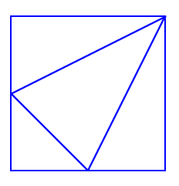
I drew this picture by drawing a line from the top right corner of a square to the midpoint of each of the opposite sides. Then I joined these two midpoints with another line.
Can you see four triangles in the square?
What fraction of the area of the square is each of these triangles?
Then I drew another picture:
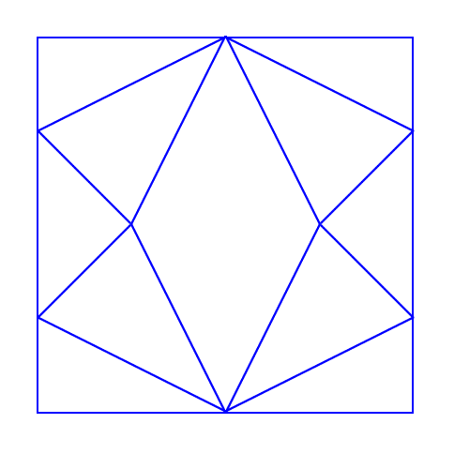
How is this made using the first square?
What is the shape that has been created in the middle of this larger square?
What fraction of the total area of the large square does this shape take up?

Rectangle Tangle https://nrich.maths.org/1048

Age 7 to 11

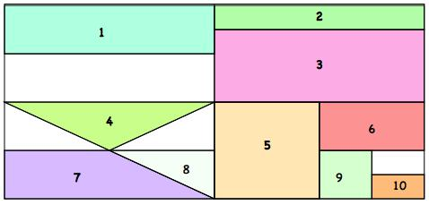
The large rectangle above is divided into a series of smaller quadrilaterals and triangles. Each of the shapes is a fractional part of the large rectangle.
Can you untangle what fractional part is represented by each of the ten numbered shapes?

