Dear Parents and Carers,
As we approach our Christmas production, we have attached the links to the songs the children will be singing. We will be practising these songs at school so the children feel confident and prepared for the performance.
Extra practice at home is always helpful and very much appreciated.
Enjoy singing along with them!
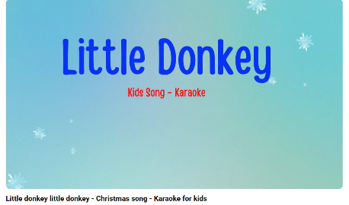
Little Donkey:
https://youtu.be/C3TECIJwVFM?si=fpCBdwq2OXvdB-sF


Away in a manager:
https://youtu.be/DLFpR4gjS54?si=bQSF3HvekecZqEv7

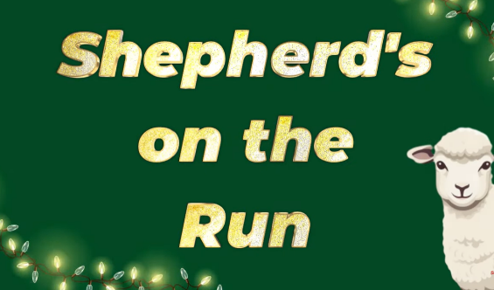
Shepherds on the run:
https://youtu.be/nqS1hA9ldOE?si=8npjaHAdrlEXE_cE

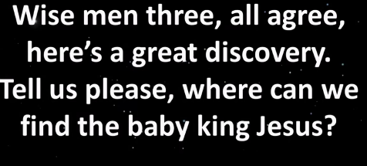
Wise Three men:
https://youtu.be/KOw2tEHqirA?si=UfxjUmGpyOhGomJR

Thank you,
The Year Two team

