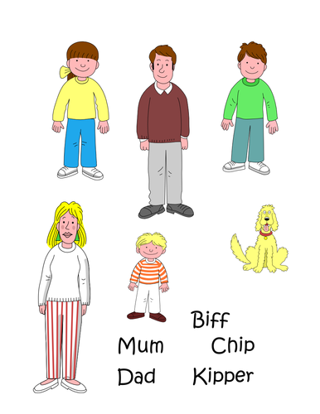
Floppy
Chip
Mum
Chip
Kipper
Dad
Biff
Biff
Biff
Dad
Biff

