Some parents have asked for suggestions as to which books they could try other than the ORT Biff, Chip & Kipper books. Here are some suggestions. Most are in sets depending on the reading level your child is currently on.

Hope this helps!
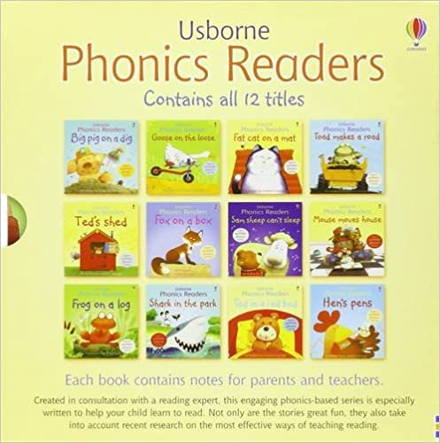 | Usborne Phonics Readers  12 Book Set Paperback
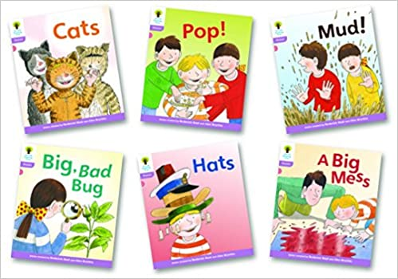 | Oxford Reading Tree: Level 1+: Floppy's Phonics Fiction: Pack of 6  (You can buy sets which cover each level/stage)
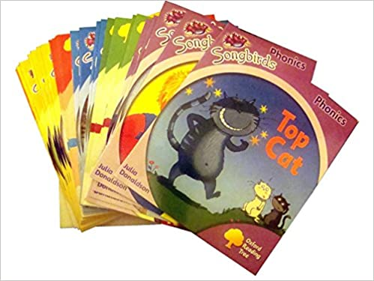 | Oxford Reading Tree, Songbirds Phonics Collection 36-Books Set RRP128.82 (Stage 1+, 2, 3, 4, 5 and 6) (Oxford Reading Tree)
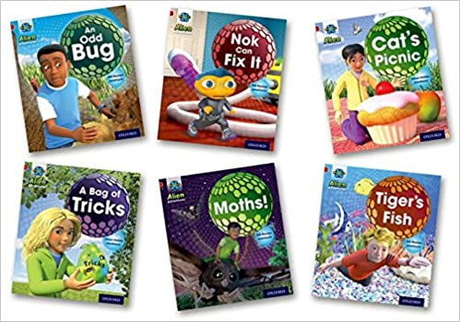 | Project X: Alien Adventures: Red: Mixed Pack x 6
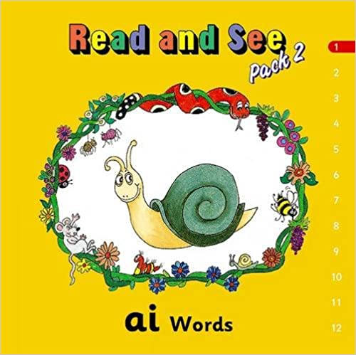 | Jolly Phonics Read and See: Digraphs Pack
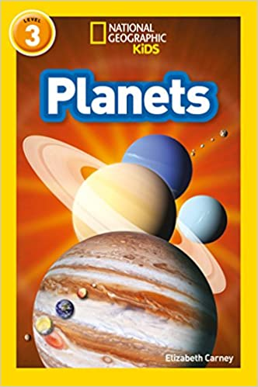  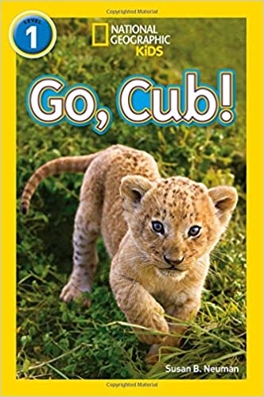 | National Geographic Kids Readers

