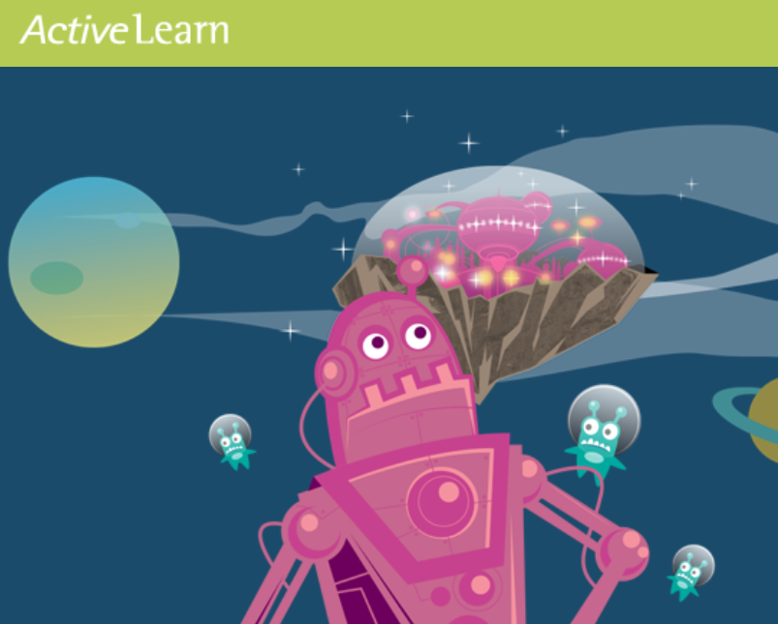
Dear Parents and carers,

As you are aware we are unable to send home reading books at this time, due to government guidance. However, we are keen for the children to have access to reading books at their own level, that offer meaningful ways for them to continue to develop reading skills.

In order for them to do this, we have purchased ‘Active Learning’. This is an interactive, online resource where the children can access reading books allocated to them.

The Bug Club section of Active Learning is a whole-school reading programme that gives children their own login details and provides the opportunity for children to read at home. Class teachers are able to select a range of books appropriate for your child to read. These books will appear in children’s ‘My Stuff’ area on their personal homepages.

The following information is your child’s login. You can access the site through any device with an internet connection.

Website: https://www.activelearnprimary.co.uk/login?c=0&l=0

Username: Child’s first name and first initial of their surname e.g. Joe Bloggs would be: JoeB
(capital letters for the first initial and for the first letter of the surname)

RK Password: rk123
RY Password: ry123

School Code: mwtj

If you or your child have any problems logging on, or accessing their account please do not hesitate to speak with us.

We hope the children find this a fun and engaging way to read!

Thank you for your continued support,

The Reception Team

