Maths - 30.6.20 - WALT: draw line graphs and solve problems involving line graphs.

Q1.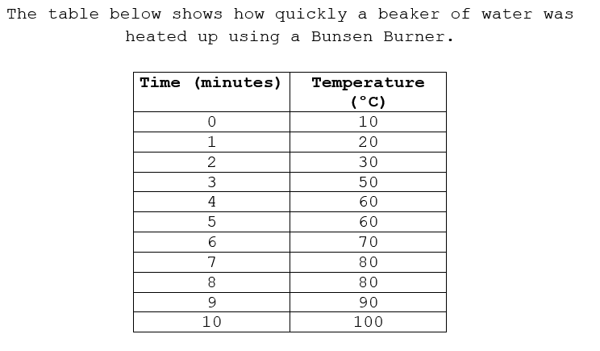 | 
Q2 .Draw the graph on the squares in your book. 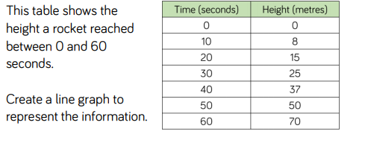 | Q3.  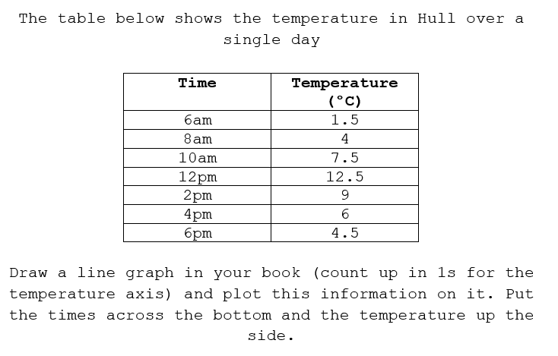
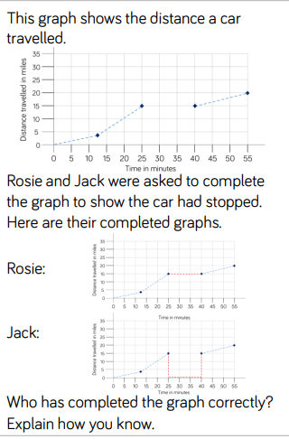  Q4. | 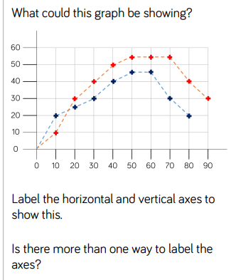  Q5.

Reading 30.06.20

Mars is the fourth furthest planet from the Sun, located between Earth and Jupiter, and is the second smallest planet in our solar system after Mercury. Named after the Roman god of war, Mars is often described as ‘the Red Planet’ because of its reddish hue. The atmosphere on Mars is made up of mainly carbon dioxide, meaning that the planet does not yet support life.

Missions to Mars It is crucial to launch a mission to Mars at the right time because Earth and Mars are always moving. It is necessary to calculate the distance between the two planets at any one time and to prepare accordingly.

As of 2019, there have been 56 missions to Mars, of which only 26 have been successful. This shows just how difficult reaching the Red Planet can be. None of these missions have been manned by humans but there is currently one Mars rover operational. There are also six active satellites orbiting Mars, providing us with plenty of data about the planet.

Why Mars?
Earth sits between Venus and Mars. Both planets are sometimes visible to the naked eye from Earth! The distance between them varies throughout their orbits of the Sun, but Mars is not the closest planet to Earth – Venus is. The closest possible distance between Earth and Venus is approximately 38 million kilometres, while the closest distance between Earth and Mars is around 55 million kilometres. Why, then, are most of Earth’s exploration efforts directed at the Red Planet? The answer lies in the environments of Mars and Venus.

Venus, Earth’s smaller sister, is blisteringly hot and has a thick atmosphere which could melt a block of lead as easily as an ice cream on Earth. Mars, on the other hand, is smaller and much colder. It is the most habitable planet next to Earth because:

• its soil contains traces of water to extract;
• it gets enough sunlight to use solar power;
• gravity is 38% as strong as on Earth, which, it is believed, humans could adapt to;
• the atmosphere somewhat protects from the Sun’s radiation;
• Mars’ day, called a ‘sol’, is only a little longer than Earth’s.

The human race is very keen to prove that there is a possibility for life on other planets, and Mars is thought to be the most likely place to find that proof.

The Mars Rover

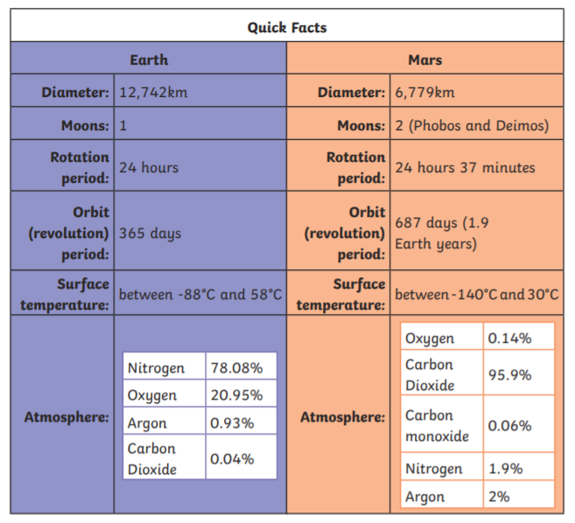
The Curiosity rover is a robotic car which is currently exploring the surface of the planet. It is nuclear-powered and the fourth rover sent to Mars in 16 years. It was launched on 26th November 2011 and landed on 6th August 2012. Curiosity uses the most advanced scientific equipment ever used on Mars. The main goals of the mission, which forms part of NASA’s Mars Science Laboratory, are to:

• study Martian climate and geology;
• search for water;
• find out whether Mars could have ever supported life.

Glossary

geology – The science which deals with the physical structure and substance of a planet.
radiation – Energy emitted by the Sun, some of which is dangerous to humans when not absorbed by the atmosphere of a planet.

Questions
1. Find and copy the correct word to complete the sentence.
Mars is named after the god of…….

2. Which of these are reasons why Mars is a good place to explore?
- Mars gets enough sunlight to use solar power.
- A day on Mars is very short.
- There is no gravity on Mars.
- There is a little water in the soil on Mars.

3. How many moons does Mars have and what are their names?
4. What is a day called on Mars and how long is it?
5. Find and copy a word from the text which means ‘working'.

Phases of the moon
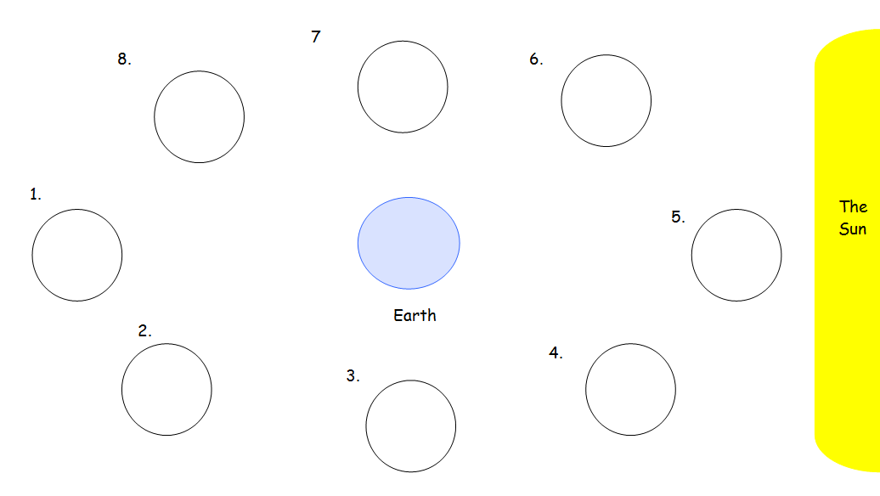
Phases of the moon

