Maths Pirate Challenge - Day 2

Challenge 1 - Fraction Flags!

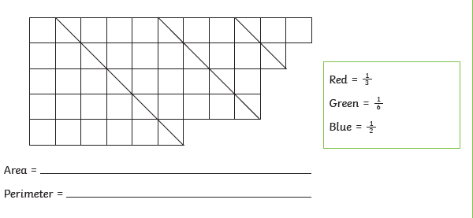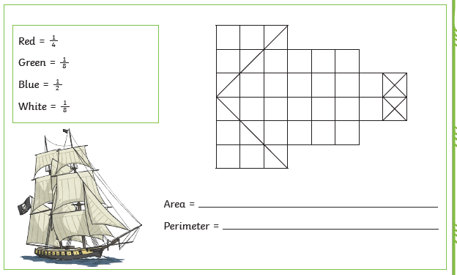

Challenge 2 - Decimal Mosaic
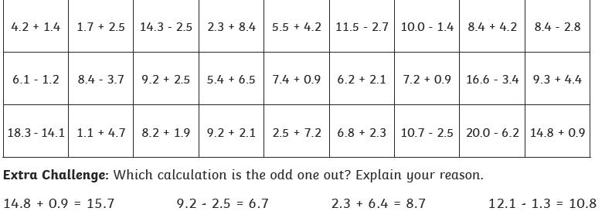
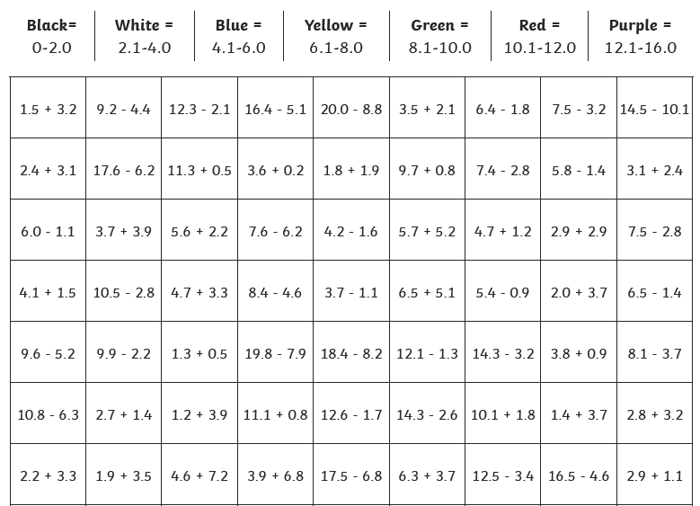

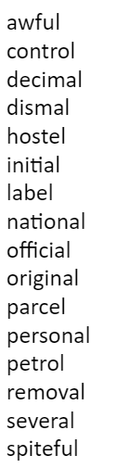
Spelling 23.06.20

Which of the words are synonyms for these words?
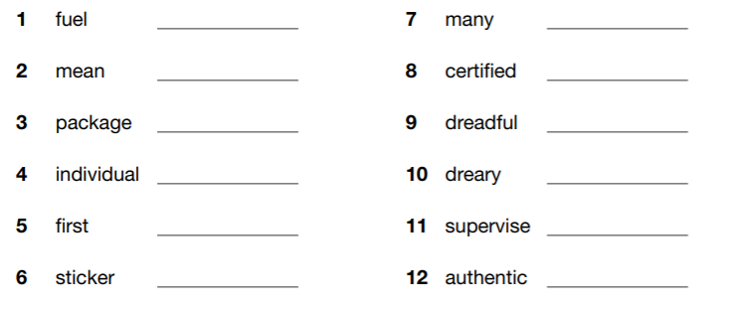

Spelling 23.06.20

Which of the words are synonyms for these words?

23.06.20 Reading - World Oceans

In 1992, the Canadian government first proposed setting up a World Ocean Day during the Earth Summit in Rio de Janeiro. The United Nations (UN) officially recognised 8th June as World Oceans Day in December 2008. The objective of the day then and now is to raise awareness of the vital importance of our oceans and the role they play in sustaining a healthy planet. It also aims to inform and educate people about the negative impact that human actions have on the ocean and the importance of finding ways in which to conserve, protect and sustain the ocean for the future.

Oceans cover over 70% of the Earth’s surface and they contain around 96% of all the water on the planet. Oceans are the world’s largest habitat and are home to a wide variety of creatures and living organisms. There are 5 oceans on Earth: the Pacific, the Atlantic, the Arctic, the Indian and the Southern.

Interesting Fact
Covering around 30% of the Earth’s surface, the Pacific Ocean is Earth’s largest ocean. The name ‘Pacific Ocean’ means ‘peaceful sea’ in Latin.

Although largely unexplored, the oceans play a major role in everyday life all around the globe. They provide about 70% of the oxygen that we breathe, and many people consider them to be the lungs of our planet. Another of the ocean’s important roles is to soak up energy in the form of heat and distribute it evenly throughout the Earth. It also helps to absorb about one-quarter of the carbon dioxide (CO2) that we humans create when we burn fossil fuels such as oil, coal and natural gas.

Did You Know…?
The Great Barrier Reef, which is in the Pacific Ocean and measures around 2,600km, is visible from the Moon! It is one of the planet’s richest ocean habitats and is home to more than 1,500 species of fish, 134 species of sharks and rays and more than 30 species of vulnerable marine mammals.
Questions
1. Why do you think it took 16 years for the UN to recognise World Oceans Day?

2. Find and copy one word that is a synonym for ‘crucial’.

3. How much of the Earth’s water is contained in oceans? Tick one.
- 70%
- 50%
- 96%
- 69%

4. Which ocean means peaceful sea in Latin?

5. Although largely unexplored… What does the subordinate clause tell us about the ocean?

6. What is created when we burn fossil fuels? Tick one.

- oxygen
- carbon dioxide
- nitrogen
- carbon monoxide

