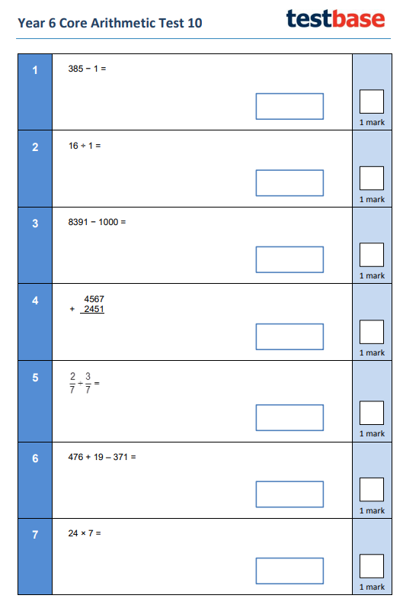

WALT: apply our maths knowledge to a variety of questions within a time limit.



Grammar Session

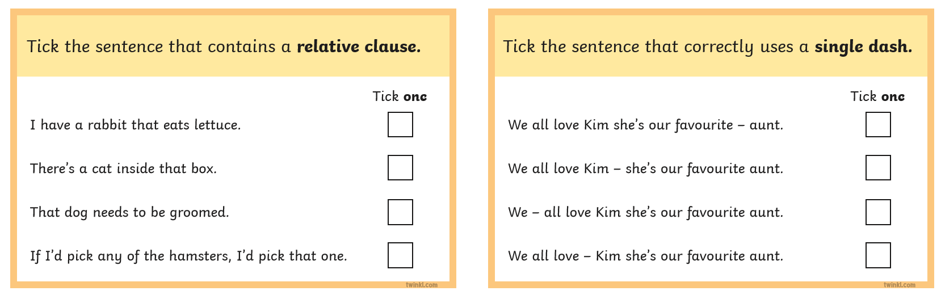

Reading Session

Dale was in the garden playing fetch with Patch, a tiny brown and white puppy they had brought home only three days before. Quite unexpectedly, Dale heard a loud rumble and saw, from the corner of this eye, flashes of light in the sky. “What is happening?” muttered Dale. Suddenly, Dale heard Mum shouting from the kitchen. “Get inside quickly, Dale!” she yelled with urgency in her voice. This worried Dale, so he swiftly ran towards the house. Unsure what to make of the situation, Patch sauntered after him, stopping occasionally to shake the rain from his fur. “Mum, why is the sky making strange noises and what are all of those lights?” asked Dale. “It is thunder and lightning, Dale,” explained Mum.
Questions
- Find and copy an adverb from the text which means the same as ‘quickly’.
- How long had Dale had Patch?
- What do you think Dale and Patch did next?
- How does the author show the reader that Patch is not really bothered about the thunderstorm?
Free Write


