Maths Skills Check - 6.7.20
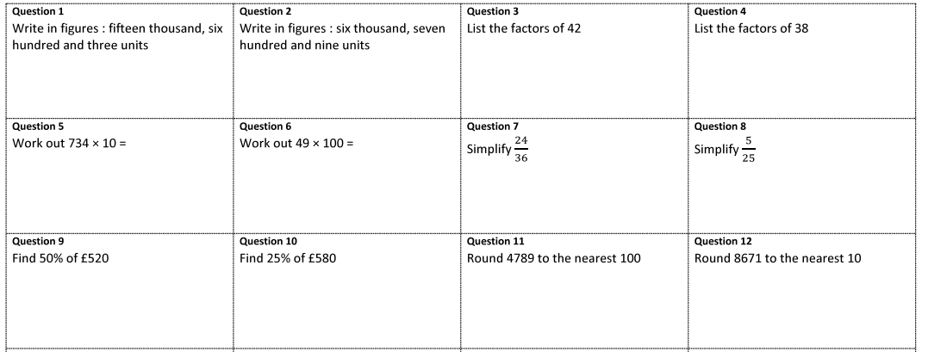
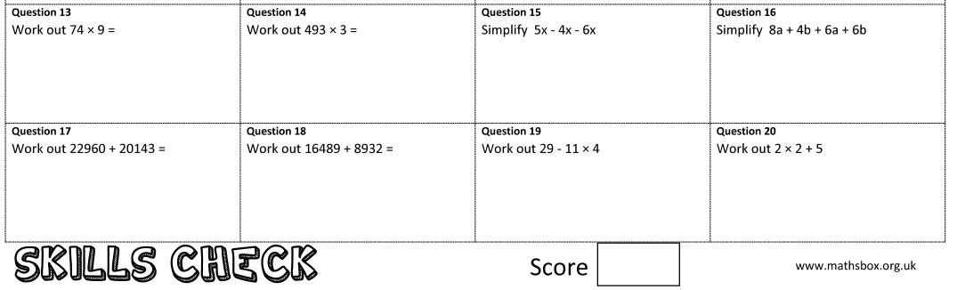

NAME: ____________________________________________________________

Year 6 Transition – English
The Mystery of the Aurora Borealis
Session 1
Starter:
All – How do you feel towards the idea of winter? What do you most look forward to? Challenge – Can you think of a time you have been uncomfortably cold? Why did you feel like that? How did it change your behaviour?
Expert – What is the coldest thing you can think of? The more ambitious and creative the better! Can you make this into a simile or metaphor?
The Wonder of the Aurora Borealis
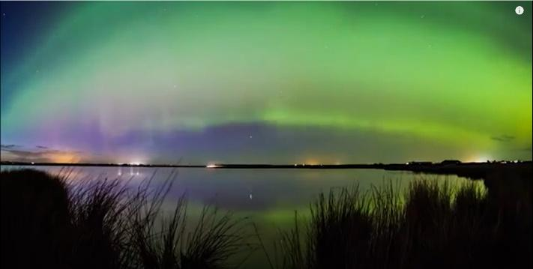
The Aurora Borealis, more commonly known as the Northern Lights, is created when a burst of solar energy ejects gas onto the surface of the sun! The science behind the Northern Lights is complicated, but the simplest explanation explains that the natural phenomenon is the result of a collision of particles that produce dazzling auroral light when they collide.
Seeing the Northern Lights is on many people’s bucket lists; it is a rare and exceptionally special event to see and usually only in specific parts of the world during very specific dates.
The Lights can only be viewed in their full glory in remote and unpolluted parts of the world. These places are usually some of the coldest and Northernly regions of our globe, where humans are closest to undisturbed natural beauty.
If you can, there are some awe-inspiring videos on Youtube which show the intrinsic and sublime patterns in the night sky.
https://www.youtube.com/watch?v=fVsONlc3OUY https://www.youtube.com/watch?v=T75IKSXVXlc
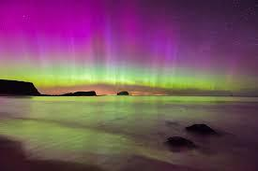
As you watch, list and name as many colours as you can see in the clip. Can you describe how they move with ambitious vocabulary? Can you create a creative and effective metaphor for the movement of the lights?
Your task will be to create a first-person narrative piece of extended, descriptive creative writing. You will be imagining that you are there watching the Northern Lights in person.
Today your task is to come up with some vocabulary and phrases you would like to use.

Grammar 6.07.20
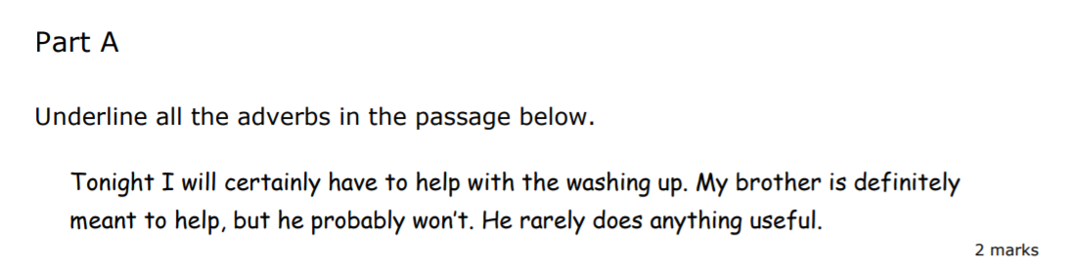

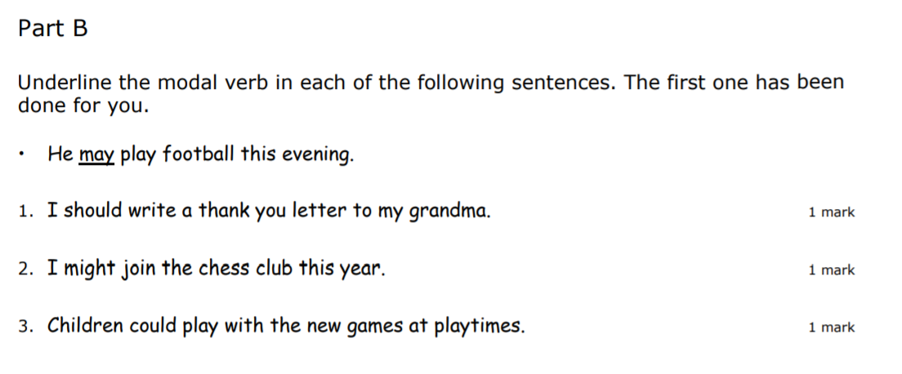

History Transition Work
Task 1:  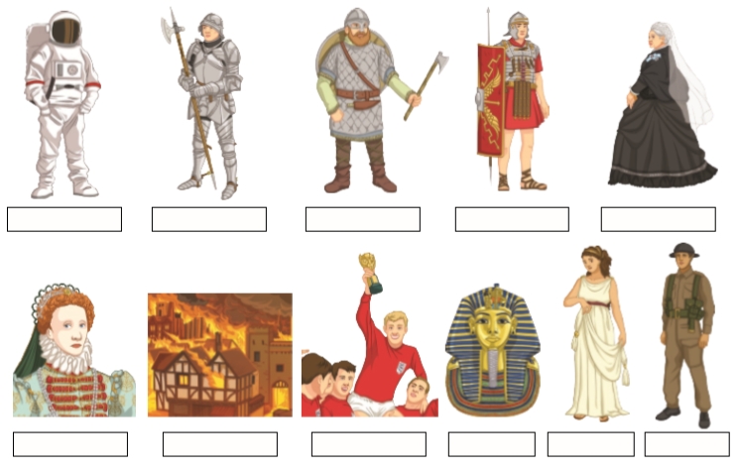 | Task 2:  What was your favourite topic in History at primary school?  Explain what you liked about it.  _____________________________________________________________________________________________________________________________________________________________________________________________________________________________________________________________________________________________________________________________________________________________________________________________________________________________________________________________________________________________
Task 3:  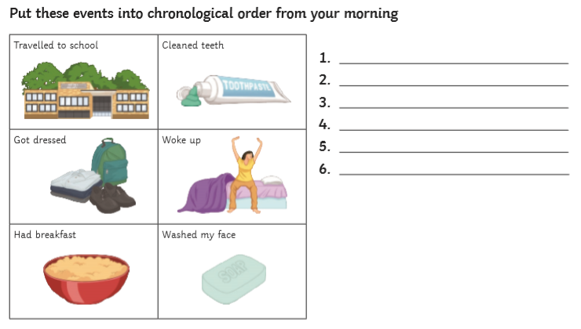 | Task 4:  Create a timeline of your life.

