Maths - 1.7.20 - WALT: identify parts of a circle.

Q1.  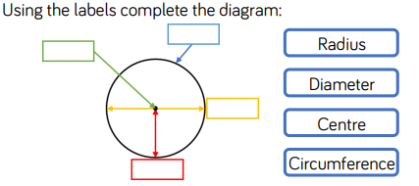 | Q2.  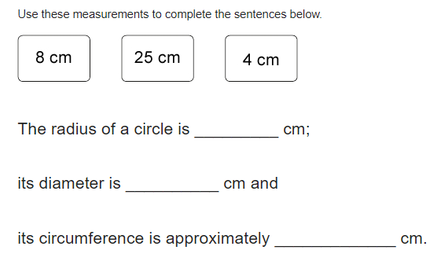
Q3.  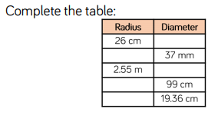 | Q4.  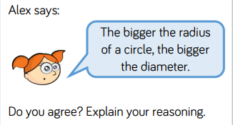
Q5.  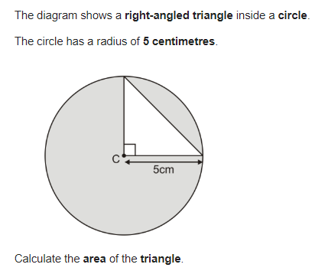 | Q6.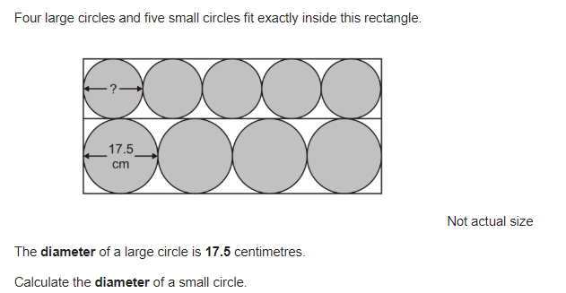

Spelling 1.07.20

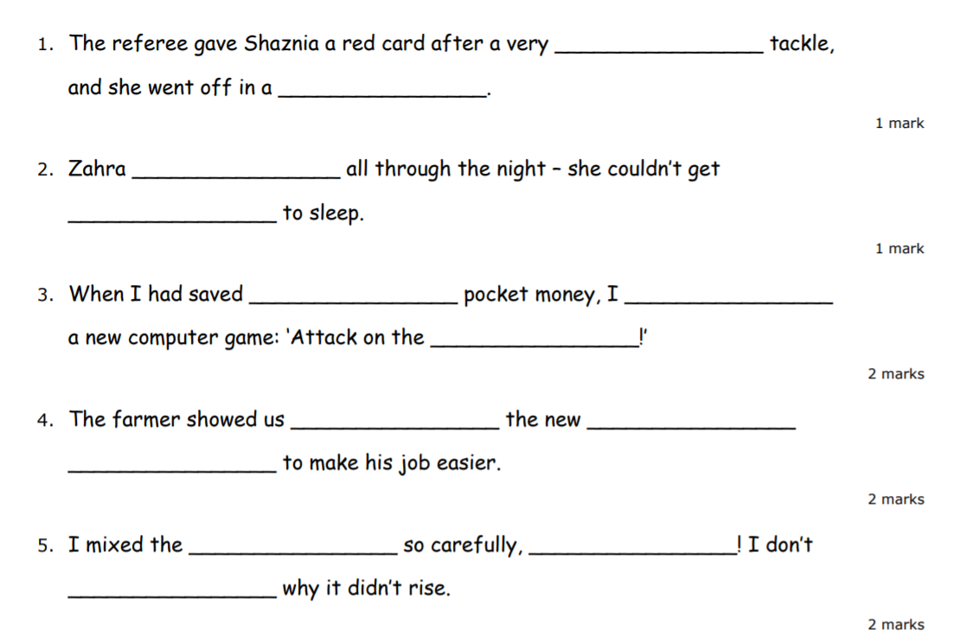
ought
bought
rough
huff
though
plough
cough
off
dough
enough
know
fort
how

Writing 1.07.20



