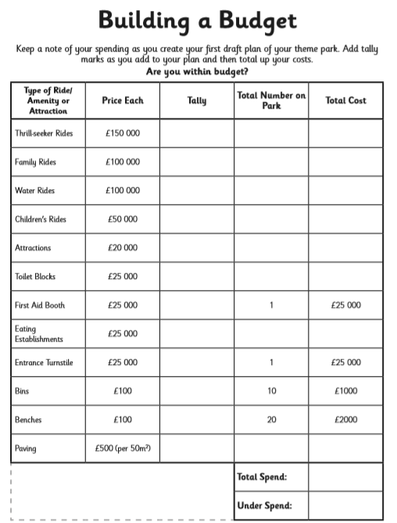

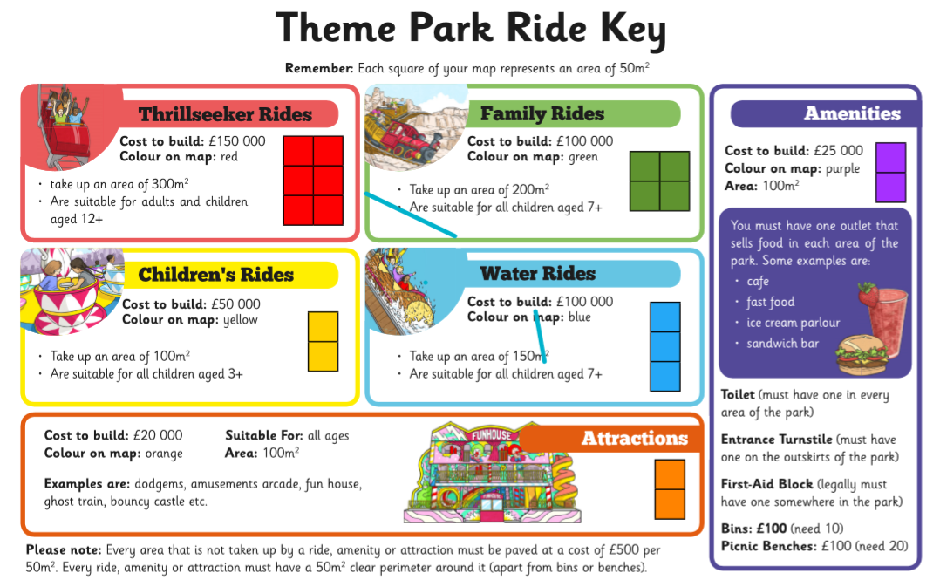

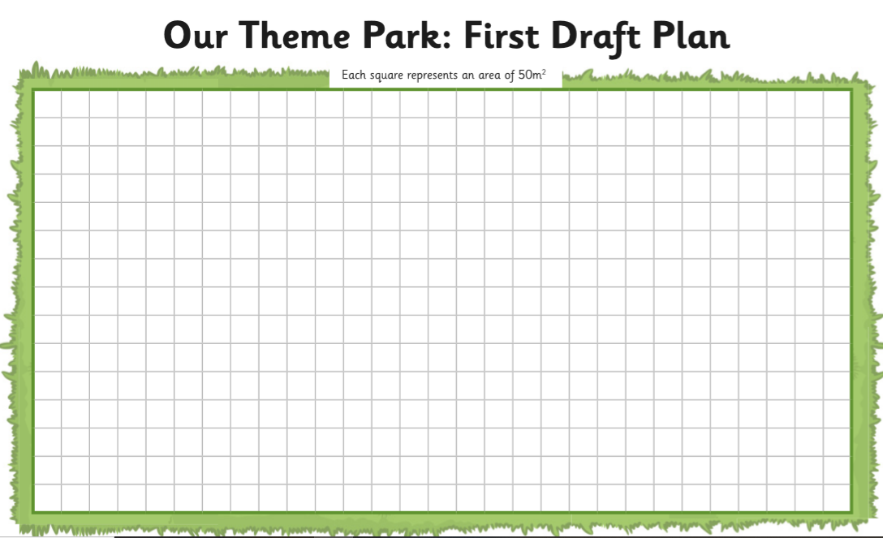

Reading 1.6.20
“The eye of the wolf” by Daniel Pennac
The boy standing in front of the wolf’s cage doesn’t move a muscle. The wolf paces backwards and forwards. He walks the length of the enclosure and back again without stopping.
He’s starting to get on my nerves, the wolf thinks to himself. For the last two hours the boy has been standing in front of the wire fencing, as still as a frozen tree, watching the wolf walking.
What does he want from me? The wolf wonders. The boy makes him feel curious. He’s not worried, (because wolves aren’t afraid of anything), just curious. What does he want?
1) How do you think the wolf is feeling in the first paragraph? Explain your answer using evidence from the text.
2) What does the description, “As still as a frozen tree,” suggest to you about the boy who is watching the wolf?

Free Write
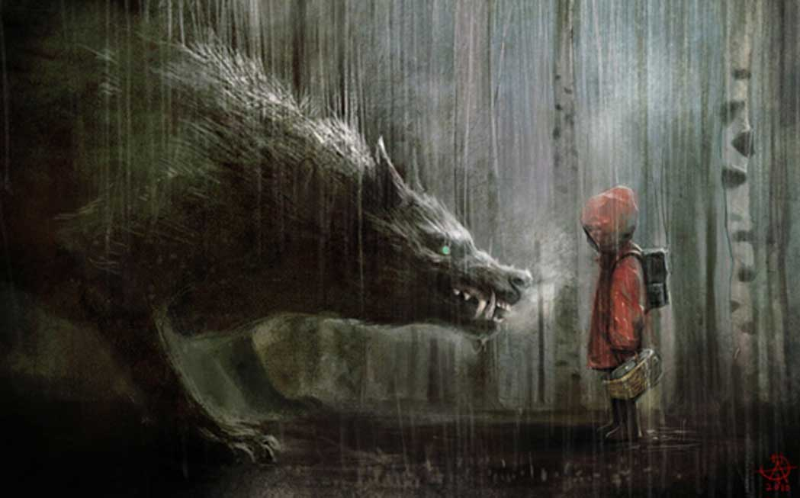

Spelling Session



