Grammar 9.7.20

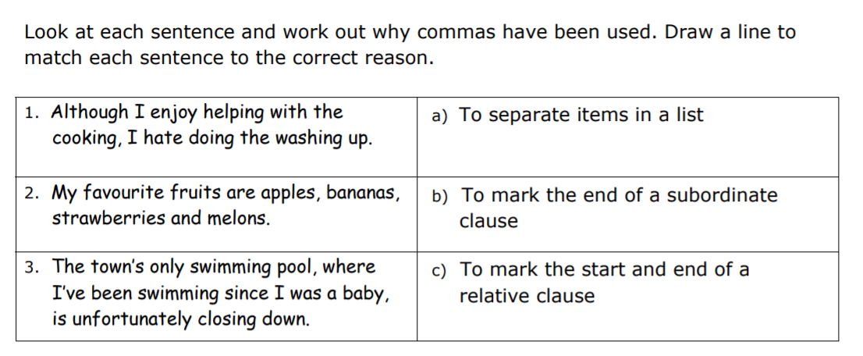

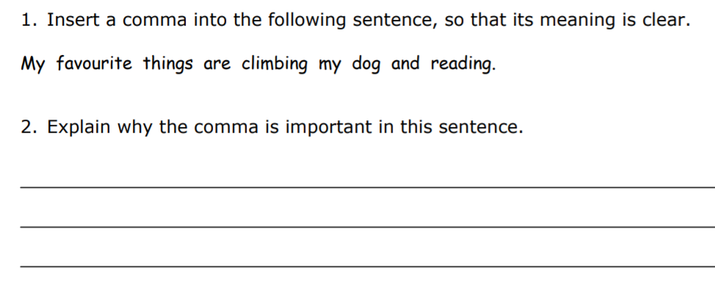

Reading 09.07.20

9:50 a.m.

I wonder if the person who gave the rainforest its name had ever actually been there. Surely, if they had, they’d have called it the ‘plant forest’ instead. Mrs Curtis, my teacher, told us that more than two thirds of the world’s plant species live in rainforest environments. That’s more than 80,000 different plants! There’s no way that I’m telling my Grandma Wilkins that! She’d be on the first plane to Brazil with her lucky gardening gloves because she really loves plants. Do you know, she once told me that she might love plants even more than she loves my mum! Don’t worry, I haven’t told my mum that.
That’s one of the reasons why I volunteered for this project – so that I could tell my grandma about all the plants. Mrs Curtis wanted one of us to spend a whole week looking at some webcams in the Amazonian rainforest.
I put my hand straight up. My best friend, Millie, said that the last time she’d seen anything move as fast as my arm was when someone told her daft brother that the bank was giving away free money. Who wouldn’t volunteer to spend the whole week looking at the Amazon? I think that I’d be really good at spotting all the different plants and animals.
As soon as Mrs Curtis looked at me, I knew that I hadn’t been picked. She had the same expression on her face that she uses to tell us that we’ve got a maths question wrong as she said, "Maybe next time, Daisy." Jack Walters got picked instead, but he changed his mind when he found out that we’re only allowed to look at the webcams during our breaks and at lunchtime. He said that there was no way that he was going to miss playing football in the playground. So Mrs Curtis ended up choosing me anyway! I don’t mind having to do normal lessons. I got nine out of ten on my spellings last week. Still can’t spell rhinnosoraus, though.
Mrs Curtis said that I have to write a journal entry to tell the rest of the class what I’ve seen on the webcams. I haven’t written a journal before. The only things I write at home are lists of my favourite songs and the things I want for Christmas, but Mrs Curtis said not to worry and to just write as I like to speak. I think that should make it easier!
A ‘green conversation’ charity set the webcams up a few years ago (I’m not actually sure what a green conversation is, or a red or yellow or pink conversation either) and when Mrs Curtis logged on with her laptop, she showed me that we can move the webcams with the arrows on the keyboard. If I want to move left or right, up or down, I just press the arrows. I can even move from camera to camera so that I can explore each layer of the rainforest! Mrs Curtis also said that the Amazon rainforest is over 5,000 miles away from our school, yet I can still move the lens in any direction I want. Sometimes, technology is amazing!
I’d love to spend all my time looking for the monkeys, or even a Bigfoot! My dad says that scientists claim there are still over five million animal species waiting to be discovered in the world, and most of those probably live in the rainforest. He wants me to keep my eyes peeled for a Bigfoot because he says, “Daisy, that’ll be like winning the lottery!”
Anyway, my dad thinks that he knows lots about the rainforest. I think that he might have read the same books as Mrs Curtis because they both said that lots of what we all take for granted comes from the rainforest. Those beans that they use to make chocolate come from there, and pineapples, too, plus the ginger that goes into yummy biscuits... even rubber for the soles of my trainers.
Millie says that her uncle has an important job at the city museum and he reckons that more than twenty-five percent (that’s a quarter) of all medicines use plants from the rainforest. So if you stay up too late and have a headache, or get an iffy tummy after you’ve eaten one of your dad’s home-made curries, the medicine that you are given could be made from rainforest plants. How amazing is that?
What I’d really like to find, though, is a new kind of flower - maybe one of those beautiful orchids. When you find something new like that, those clever people you see on the documentary channels sometimes let you name them. I’d call mine the Wilkins orchid, after Grandma Wilkins. That would make her feel very important, and she tells me that she’s always wanted to be a VIP!

Questions:

1. What is the meaning of the word ‘volunteered’?

2. Draw lines to match these figures with the correct information.

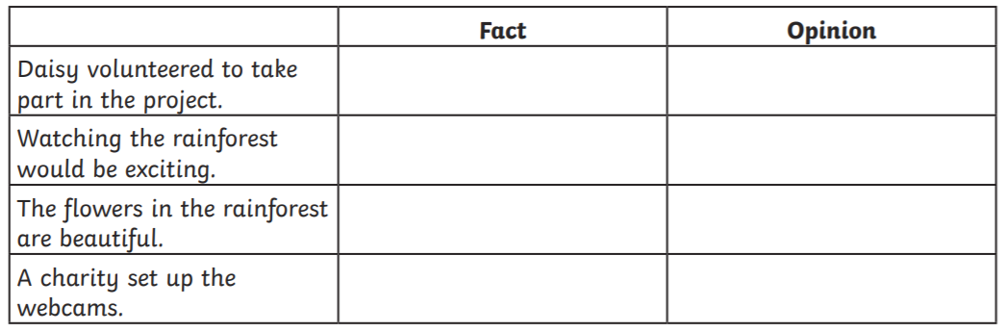

3. Complete the table by showing whether each statement is a fact or an opinion.

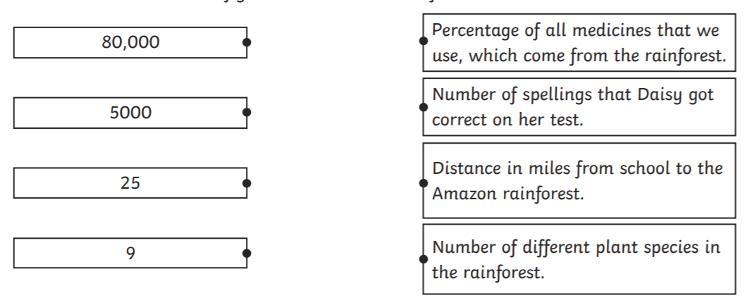

4. How do you think Daisy feels about being chosen to take part in the project? Give evidence for your answer.

5. What kind of relationship do you think Daisy has with her grandma? Use evidence from the text to support your answer.

RE - Buddhism - The Eightfold Path





