

Spelling Session

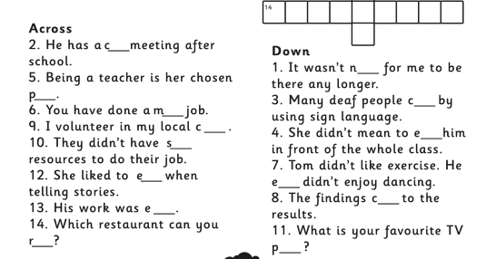
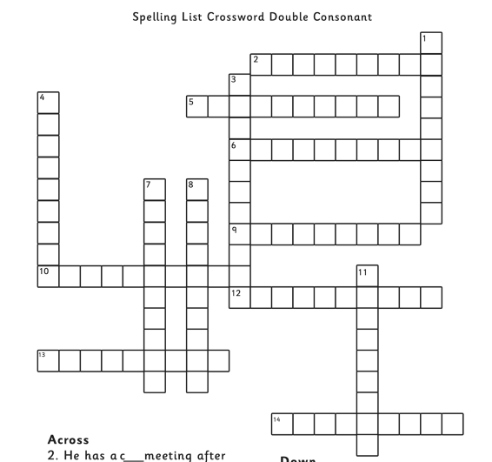
Reading Session

Seismograph
A seismograph (say: size-mo-graf) is a special piece of equipment that records earthquakes. Seismometers are securely fastened to the Earth, so when the ground starts to shake, the instrument’s case moves too. What doesn’t move is a weight that hangs on a string inside the case. When there is an earthquake, the case shakes with the ground but the weight does not, and it draws a line to show how much the ground shook. Scientists use seismograms (graphs produced by the seismograph) to measure how big each earthquake is.

Questions
- What is a seismograph?
- How does a seismograph work?

Geography Postcard



