Maths Skills Check - 7.7.20

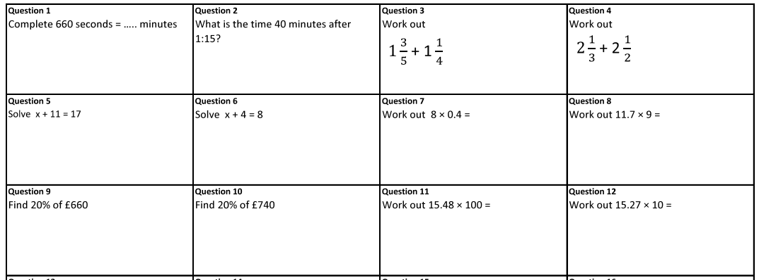
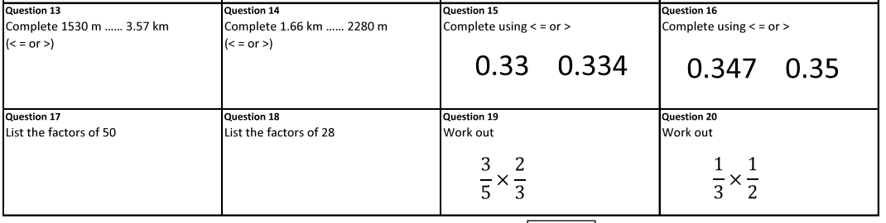

NAME: ____________________________________________________________

Year 6 Transition – English
The Mystery of the Aurora Borealis
Session 2

To inspire you, here is an opening paragraph of descriptive writing.
The cold that had seemed mild at first now numbed my face like a freshly stung wasp sting. Whatever residual heat I had absorbed in the lodge was gone, it had been my buffer, but not it was gone – wasted. With each breath more heat rose in puffs of white vapour, with each gust of the wind more heat dissipated into the whiteness, with each step the rocks and ice pulled more heat from my very bones. I stopped composing wintry poetry about icicles and the spectre of the world under a pristine white blanket and instead surrendered, tucked my chin to my chest and made peace with the raw, Siberian night. All the while I fervently tried to wish away the ice that clung to my new beard. How can there be so much to learn about life under the lights?

Can you highlight and label:
3 quotes which show the man’s coldness?
Metaphor
Simile
Repetition
3 examples of ambitious vocabulary.

From the paragraph above, can you choose what you think is the most effective sentence to describe the cold. Justify your choice of quote in a clear Point, Evidence and Explain paragraph.

The Planning
Before starting your writing, it is crucial you plan your work. It is up to you how you design your plan, usually a mind-map or list for each paragraph works best.
A good piece of writing usually starts by establishing the scene and the narrator.
Around your plan for paragraph one, make notes on what you can: See? Hear? Feel? Touch? Smell?
Challenge: How are you going to ‘Show not tell’ the reader about your emotions and reaction to the Northern Lights for the first time.
Expert: Can you create a simile, metaphor and a line of personification to describe any of the features of the picture

Paragraphs 2-3 (Middle):
Zoom in/Feelings the first time you see the Northern Lights

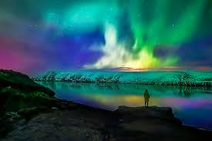
Paragraph 1 (Beginning): Atmosphere and Setting

Paragraph 5 (Resolution): Could this be linked to how you are feeling or how your feelings have changed?

Paragraph 4:
Action/Zoom in on a different, unusual action

Grammar 07.07.20

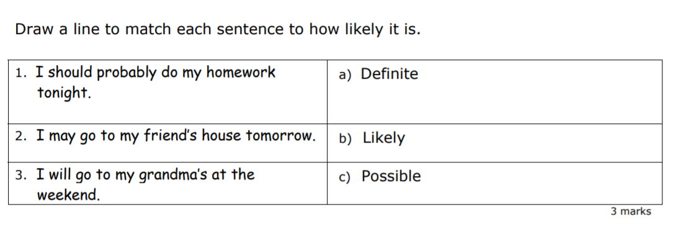

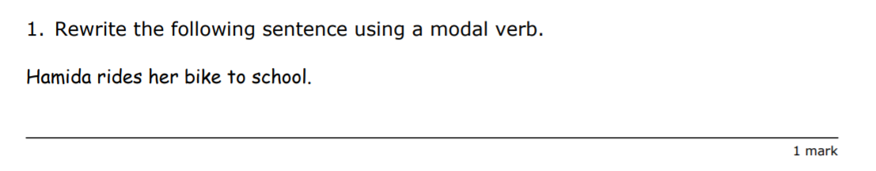

Geography Transition Work


