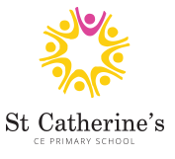
Year 1 Home Learning
Week 1 and Week 2.
Dear Parents and Carers,

We hope you are all keeping well and safe too! We have provided a range of ideas and learning activities for you to try at home with your child. We understand that these are unusual and difficult circumstances for everyone. ‘Home-schooling’ can be challenging for many different reasons. Please take a look at the activities that we have uploaded to the website and see how they best fit for you and your family. Your best is enough!

Year 1 team
Dear Year 1 children,

We hope you are all keeping well and safe at home. We miss you all so very much!
We know how much you all enjoy and love learning, so try and keep this up at home. Most importantly, have fun in what you do and stay safe. We look forward to seeing you all very soon.

Mrs Ross, Miss Wheeler, Miss Townsend, Mrs Shelley, Mrs Jones and Mrs Hulagu

P.E. and Well-Being.
It is really important to keep both your body and mind active during your time at home. Take a look at these online activities. They are lots of fun
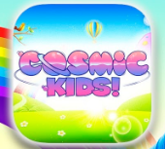
Cosmic Kids – Yoga, mindfulness and relaxation designed especially for children aged 3+, used in schools and homes all over the world. https://www.youtube.com/user/CosmicKidsYoga
There is also a Cosmic Kids App available to download.
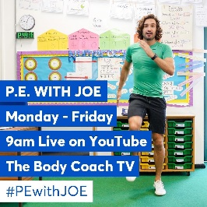
Joe Wicks ‘The Body Coach’ is live streaming daily workouts at 9:00am Monday – Friday. It’s a great way to get you energised and ready for the day ahead! https://www.youtube.com/user/thebodycoach1

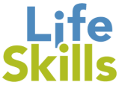
Fortnightly challenge!

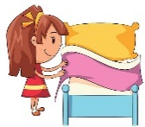
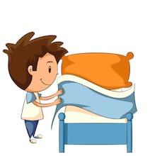
There is so much learning that can be done in your home environment. Take this time to learn a new skill and become more independent. This week we challenge you to learn how to… Make your own bed!

The real challenge is doing it every day and without being asked by a grown up!
(Mom’s & Dad’s we can but hope )

